Animal Report Book Rubric
 | 1  Do over | 2  Not very good | 3  OK | 4  Very good | 5  Awesome!
Research Folder  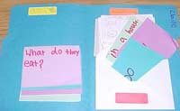 | 0, 1, 2 questions | 3 required questions answered | 5 research questions, answers on colored cards and show resources used | 6 questions | More than 6 questions
Information | One or two words or some questions not answered | Not complete sentences given for answers | 1 complete sentences for each answer | 2 sentences for each answer | More than two sentences for each answer
Pictures  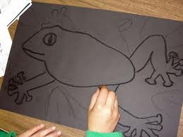 | No picture | Black and white picture or hastily drawn | One high quality colored picture on the cover of book | 2 high quality pictures | 3 or more high quality pictures
Writing Skills | No capitals and periods are used | A few sentences have capitals and periods | Most sentences have capitals and periods | All capitals are correct and all periods are correct | Advanced capitalization and punctuation skills
Neatness  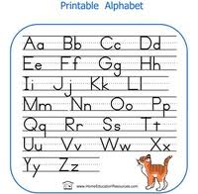 | Can’t read,  no spaces,  not on line | Some spaces,  a little hard to read | Neat and readable spaces | Very good handwriting | AWESOME! All letters are same size, spaces are equal, etc.
Name:_________________________
Animal Report Book Self-reflection Questions

1. What was your favorite part of the research assignment?

2. What was the most challenging part of creating your book?

3. If you were to create another book what would you do differently?

4. What was the purpose of creating our animal research project?

5. Tell me one fact that you learned from someone else’s book presentation?

